Readings for a Funeral

“I am the resurrection and the life,
whoever believes in me will never die.”

Table of Contents

Introduction

Selection of Old & New Testaments Readings

Prayers of the Faithful (examples)

List of some liturgical Musicians

Introduction
The Funeral Rites in the Catholic tradition seek both to comfort the bereaved and also to intercede for the dead. The emphasis is of a celebration of hope in a loving and merciful God, to whom we commend a loved one who has died.

We give thanks to God for His precious gift of life: and in particular the life of our loved one who has died. We call to mind the memories of that life but also look ahead to a life to be fulfilled; as we profess in the Creed “ …we look forward to the resurrection of the dead and the life of the world to come.”

Our faith, at this moment, is of the utmost importance. We may feel lost, alone, afraid, guilty or even angry that it seems that God has abandoned us when we need Him most. However God has not abandoned us but, by dying for us, has gone before us to break the bonds of death and reveal the resurrection. In grief we now share in what Our Lord and his Blessed Mother have already faced. Not only did they face it but they conquered it.

We think of you, Mother,
at the foot of the cross.
Your heart must have bled
to see your Son in agony.
But your joy was great
when he rose from the dead,
victorious over the powers of evil.
Mother of Sorrows,
help us through the trials and
disappointments of life.
Help us not to lose heart.
May we share with you and your Son
the joy of having courageously faced up
to all the challenges of life. Amen.

We turn to God, as we are, with tears, sadness and grief. We come with our doubts and fears asking Him to take care of our loved one. It is hard to let go and say goodbye but God will give us the strength and grace we need.

Can family or friends be involved in the funeral mass?

Certainly they can. Family or friends, who feel up to it and are able, can
(1) proclaim the Readings from the Scriptures
(2) announce the Prayer of the Faithful
(3) carry forward the gifts of bread and wine during the mass.

Also, if you have a photograph of your loved one, a family member could carry it into the church behind the coffin at the beginning of mass. The parish will arrange for a small table to be placed beside the coffin so that the photograph can be beside the coffin throughout the mass.

- TWO READERS
Reader 1 should read the Old Testament and the psalm if the psalm is NOT BEING SUNG. Then READER 2 reads the New Testament reading. You can choose the readings from the options overleaf. (There are also some child-friendly readings).
- PRAYER OF THE FAITHFUL – these can be read by 1 to 5 people.
- GIFTS OF BREAD & WINE – between 2 people can bring forward the gifts of Bread and Wine to be transformed into the Body & Blood of Christ.
- Services are live-streamed from the St Bernards via the parish website – stmarysonthehill.online
Old Testament Reading

(Choose one of the following Old Testament Readings)

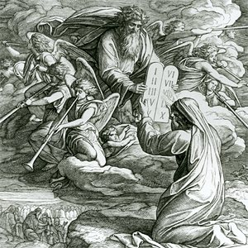

Option 1. A Reading from the Book of Job (19:1.23-27)
Job said,
“Ah, would that these words of mine were written down,
inscribed on some monument
with iron chisel and engraving tool,
cut into the rock forever.

This I know: that my Redeemer lives,
and he, the Last, will take his stand on earth.
After my awaking, he will set me close to him,
and from my flesh I shall look on God.
He whom I shall see will take my part:
these eyes will gaze on him and find him not aloof.”

The Word of the Lord.

Option 2. A Reading from the Book of Exodus (23:20-23)
The Lord says this:
‘I myself will send an Angel before you to guard you as you go and bring you to the place that I have prepared. Give him reverence and listen to all that he says. Offer him no defiance; he would not pardon such a fault, for my name is in him. If you listen carefully to his voice and do all that I say, I shall be enemy to your enemies, foe to your foes. My angel will go before you.’

The Word of the Lord.

Option 3. A Reading from the Book of Wisdom (3:1-9)

The souls of the virtuous are in the hands of God,
no torment shall ever touch them.
In the eyes of the unwise, they did appear to die,
their going looked like a disaster,
their leaving us, like annihilation: but they are in peace.
If they experienced punishments as men see it,
their hope was rich with immortality;
slight was their affliction, great will their blessings be.
God has put them to the test
and proved them worthy to be with Him;
He has tested them like gold in a furnace,
and accepted them as a holocaust.
When the time comes for His visitation they will shine out;
as sparks run through the stubble, so will they.
They shall judge nations, rule over peoples,
and the Lord will be their King forever.
They who trust in Him will understand the truth,
those who are faithful will live with Him in love;
for grace and mercy await those He has chosen.

The Word of the Lord.
Option 4. A Reading from the Book of Wisdom (4:7-15)
The virtuous man, though he die before his time, will find rest.
Length of days is not what makes age honourable,
nor number of years, the true measure of life;
understanding, this is man’s grey hairs, untarnished life, this is ripe old age. He has sought to please God, so God has loved him;
as he was living among sinners, he has been taken up.
He has been carried off so that evil may not warp his understanding or treachery seduce his soul;
for the fascination of evil throws good things into the shade,
and the whirlwind of desire corrupts a simple heart.
Coming to perfection in so short a while, he achieved long life;
his soul being pleasing to the Lord,
he has taken him quickly from the wickedness around him.
Yet people look on, uncomprehending;
it does not enter their heads that grace and mercy await the chosen of the Lord, and protection, his holy ones.

The Word of the Lord.

Option 5. A Reading from the Prophet Isaiah (25:6-9)

On this mountain, the Lord of hosts
will prepare for all peoples a banquet of rich food.
On this mountain He will remove
the mourning veil covering all peoples,
and the shroud enwrapping all nations,
He will destroy Death forever.
The Lord will wipe away the tears from every cheek;
He will take away His people’s shame
everywhere on Earth, for the Lord has said so.
That day, it will be said: See, this is our God
in whom we hoped for salvation;
the Lord is the one in whom we hoped.
We exult and we rejoice that He has saved us.

The Word of the Lord.

Option 6. A Reading from the Book of Lamentations (3:17-26)

My soul is shut out from peace;
I have forgotten happiness.
And now I say, ‘My strength is gone,
that hope which came from the Lord’.
Brooding on my anguish and affliction
is gall and wormwood.
My spirit ponders it continually
and sinks within me. This is what I shall tell my heart,
and so recover hope: the favours of the Lord are not all past,
His kindnesses are not exhausted;
every morning they are renewed;
great is His faithfulness.
‘My portion is the Lord’ says my soul
‘and so I will hope in Him.’
The Lord is good to those who trust Him, to the soul that searches for Him. It is good to wait in silence
for the Lord to save.

The Word of the Lord.

Option 7. A Reading from the book of Revelations (12:1-3)

I, John, heard a voice from heaven say to me
“Write down: Happy are those who die in the Lord!”
Happy indeed, the Spirit says;
now they can rest for ever after their work
since their good deeds go with them.

The Word of the Lord.

Option 8 A reading from the book of Ecclesiastes 3:1-11

A Time for Everything

There is a time for everything,
and a season for every activity under the heavens:
a time to be born and a time to die,
a time to plant and a time to uproot,
a time to tear down and a time to build,
a time to weep and a time to laugh,
a time to mourn and a time to dance.
a time to embrace and a time to refrain from embracing,
a time to search and a time to give up,
a time to keep and a time to throw away,
a time to tear and a time to mend,
a time to be silent and a time to speak.
I have seen the burdens laid on the human race.
All that God does is apt for its time: but although he has given us an awareness of the passage of time,
we cannot grasp the beginning or the end of what God does.

The Word of the Lord

The Responsorial Psalm
(if the Psalm is sung there is no need to get someone to read a Psalm)


Option 1 Psalm 41

R My soul is thirsting for God, the God of my life.

Like the deer that yearns
For running streams,

So my soul is yearning
for you, my God. R

My soul is thirsting for God,
The God of my life;
When can I enter and see
The face of God? R

And I will come to the altar of God,
The God of my joy.
My redeemer, I will thank you on the harp,
O God, my God. R

Why are you cast down, my soul,
Why groan within me?
Hope in God; I will praise Him still,
My Saviour and my God. R
Option 2 Psalm 23

R The Lord is my shepherd; there is nothing I shall want.

The Lord is my shepherd;
there is nothing I shall want.
Fresh and green are the pastures
where He gives me repose.
Near restful waters He leads me,
to revive my drooping spirit. R

He guides me along the right path;
He is true to His name.
If I should walk in the valley of darkness
no evil would I fear.
You are there with your crook and your staff;
with these you give me comfort. R

You have prepared a banquet for me
in the sight of my foes.
My head you have anointed with oil;
my cup is overflowing. R

Surely goodness and kindness shall follow me
all the days of my life.
In the Lord’s own house shall I dwell
for ever and ever. R

New Testament Reading
(Choose one of the following New Testament Readings)

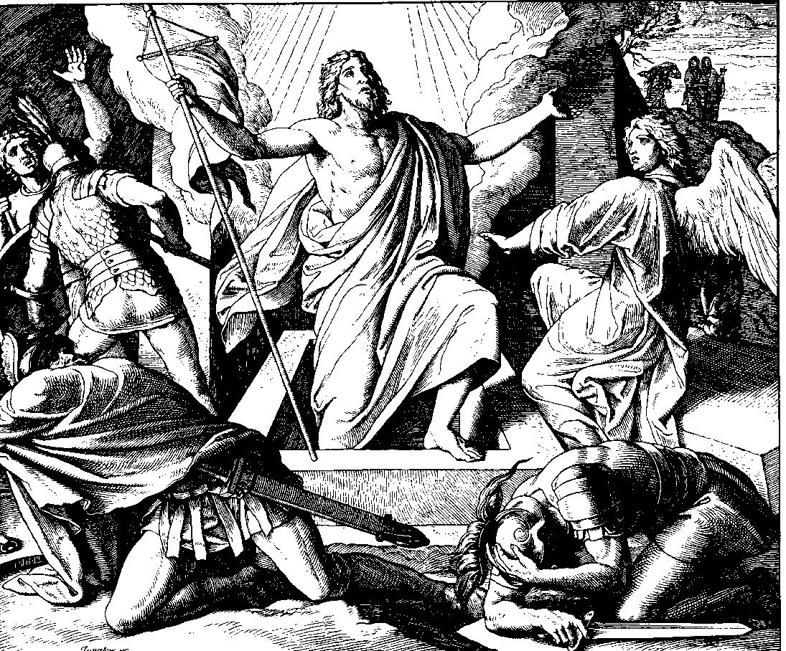

Option 1. A Reading from the Letter of St Paul to the Romans (5:5-11)

Hope is not deceptive, because the love of God has been poured into our hearts by the Holy Spirit which has been given us. We were still helpless when at His appointed moment Christ died for sinful men. It is not easy to die even for a good man – though of course for someone really worthy, a man might be prepared to die – but what proves that God loves us is that Christ died for us while we were still sinners. Having died to make us righteous is it likely that He would now fail to save us from God’s anger? When we were reconciled to God by the death of His Son, we were still enemies; now that we have been reconciled, surely we may count on being saved by the life of His Son? Not merely because we have been reconciled but because we are filled with joyful trust in God, through Our Lord Jesus Christ, through whom we have already gained our reconciliation.

The Word of the Lord.
Opotion 2. A Reading from the Letter of St Paul to the Romans. (5:17-21)

If it certain that death reigned over everyone as the consequence of one man’s fall, it is even more certain that one man, Jesus Christ, will cause everyone to reign in life who receives the free gift that he does not deserve, of being made righteous. Again, as one man’s fall bought condemnation on everyone, so the good act of one man brings everyone life and makes them justified. As by one man’s obedience many will be made righteous. When law came, it was to multiply the opportunities of falling, but however great the number of sins committed, grace was even greater; and so, just as sin reigned wherever there was death, so grace will reign to bring eternal life thanks to the righteousness that comes from Jesus Christ our Lord.

The Word of the Lord.

Option 3. A Reading from the Letter of St Paul to the Romans. (6:3-9)

When we were baptised in Christ Jesus we were baptised in His death; in other words, when we were baptised we went into the tomb with Him and joined Him in death, so that as Christ was raised from the dead by the Father’s glory, we too might live a new life.
If in union with Christ we have imitated His death, we shall also imitate Him in His resurrection. We must realise that our former selves have been crucified with Him to destroy this sinful body and to free us from the slavery of sin. When a man dies, of course, he has finished with sin.

But we believe that having died with Christ we shall return to life with him; Christ, as we know, having been raised from the dead will never die again. Death has no power over Him any more.

The Word of the Lord.

Option 4. A Reading from the Letter of St Paul to the Romans. (8:14-23)

The Spirit Himself and our spirit bear united witness that
we are children of God. And if we are children we are heirs as well; heirs of God and coheirs with Christ,
sharing His suffering so as to share His glory.

I think that what we suffer in this life
can never be compared to the glory, as yet unrevealed,
which is waiting for us.
The whole creation is eagerly waiting for God to reveal His sons.

From the beginning till now the entire creation,
as we know, has been groaning in one great act of giving birth;
and not only creation,
but all of us who possess the first-fruits of the spirit,
we too groan inwardly as we wait for our bodies to be set free.

The Word of the Lord.

Option 5. A Reading from the Letter of St Paul to the Romans
(8:31-35, 37-39)
With God on our side who can be against us? Since God did not spare His own Son, but gave Him up to benefit us all, we may be certain, after such a gift, that He will not refuse anything He can give.
Could anyone accuse those that God has chosen? When God acquits, could anyone condemn? Could Christ Jesus? No! He not only died for us - He rose from the dead, and there at God's right hand He stands and pleads for us.

Nothing therefore can come between us and the love of Christ, even if we are troubled or worried, or being persecuted, or lacking food or clothes, or being threatened or attacked. These are the trials through which we triumph, by the power of Him who loved us.
For I am certain of this: neither death nor life, no angel, no prince, nothing that exists, nothing still to come, not any power, or height or depth, nor any created thing, can ever come between us and the love of God made visible in Christ Jesus our Lord.

The Word of the Lord.

Option 6. A Reading from the Letter of St Paul to the Romans
The life and death of each of us has its influence on others; if we live we live for the Lord; and if we die, we die for the Lord, so that alive or dead we belong to the Lord. This explains why Christ both died and came to life, it was so that He might be Lord both of the dead and of the living. We shall all have to stand before the judgement seat of God; as Scripture says: By my life – it is the Lord who speaks – every knee shall bend before Me, and every tongue shall praise God. It is to God, therefore that each of us must give account of himself.

The Word of the Lord.

Option 7. A Reading from the First Letter of St Paul to the Corinthians (15:51-57)

I will tell you something that been secret; that we are not all going to die, but we shall all be changed. This will be instantaneous, in the twinkling of an eye, when the last trumpet sounds. It will sound, and the dead will be raised and we shall be changed as well.

When this mortal nature has put on immortality, then the words of scripture will come true: Death is swallowed up in victory.
Death, where is your victory? Death where is your sting? Now the sting of death is sin, and sin gets its power from the Law. So let us thank God for giving us victory through our Lord Jesus Christ.

The Word of the Lord.

Option 8. A Reading from the Second Letter of St Paul to the Corinthians (4:14-5:1)

We know that He who raised the Lord Jesus to life will raise us with Jesus in our turn, and put us by His side and you with us. You see, all this is for your benefit, so that the more grace is multiplied among people, the more thanksgiving there will be, to the glory of God.
That is why there is no weakening on our part, and instead, though this outer man of ours may be falling into decay, the inner man is renewed day by day. Yes, the troubles which are soon over, though they weigh little, train us for the carrying of a weight of eternal glory which is out of all proportion to them. And so we have no eyes for things that are visible, but only for things which are invisible; for visible things last only for a time, and the invisible things are eternal.
For we know that when the tent that we live in on earth is folded up, there is a house built by God for us, an everlasting home not made by human hands, in the heavens.

The Word of the Lord.

Option 9. A Reading from the First Letter of St Paul to the Thessalonians (4:13-18)

We want you to be quite certain, brothers, about those who have died, to make sure that you do not grieve about them, like the other people who have no hope. We believe that Jesus died and rose again, and that it will be the same for those who have died in Jesus; God will bring them with Him.
With such thoughts as these you should comfort one another.

The Word of the Lord.

Option 10.
A Reading from the Letter of St Paul to the Philippians
(3:20-21)
For us, our homeland is in heaven, and from heaven comes the Saviour we are waiting for, the Lord Jesus Christ, and He will transfigure these wretched bodies of ours into copies of His own glorious body. He will do that by the same power with which He can subdue the whole universe.

The Word of the Lord.

Option 11.
A Reading from the Second Letter of St Paul to Timothy
(4:6-8)
I am already on the point of being sacrificed; the time of my departure has come.
I have fought the good fight. I have finished the race. I have kept the faith. All there is to come for me now is the Crown of Righteousness reserved for me, which the Lord, the righteous judge, will give to me on that Day; and not only to me but to all those who have longed for His appearing.

The Word of the Lord.

Alternative New Testament Readings:
Easy Reading: Child-Friendly

Option 1
A reading from the letter of St Paul to the Romans (8:14-18)
Brothers and Sisters
Those people who are led by God’s Spirit are his children.
God’s Spirit does not make us slaves who are afraid of him.
Instead we become his children and call him Our Father.

God’s Spirit lets us know that together with Christ
we will be given a share in what God has promised.
We will share in the glory of Christ, because we have suffered with him.

I am sure that what we suffer now cannot compare with the glory that God will show us.

The Word of the Lord

Option 2
A reading from the letter of St Paul to the Romans (8: 35,37-39)

Brothers and Sisters
Can anything separate us from the love of Christ?
Can trouble, suffering and hard times? Can hunger or danger or death?

In everything we have won more than a victory because of Christ who loves us.
I am sure that nothing can separate us from God’s love-
Not life nor death, not angels nor spirits,
Not the present nor the future, Not powers above nor powers below.
Nothing in all creation can separate us from God’s love for us revealed in Christ Jesus our Lord.

The Word of the Lord.

Option 3
A reading from the letter of St Paul to the Romans (14:7-9)

Brothers and Sisters
Whether we live or die
It must be for God, rather than for ourselves.
Whether we live or die, we live or die for the Lord.
That means that alive or dead we belong to the Lord.
Jesus Christ died and rose to life so that he would be Lord
of the dead and of the living.

The Word of the Lord

Prayer of the Faithful (Examples) (add in names where appropriate)

- We pray for …………. and hold his/her memory dear.
May his/her soul now rest in God’s eternal peace.
Lord hear us.

- We pray for ………….’s family,
……………………………………………………………..
and the whole family circle.
May God help them in the days of grief that lie ahead.
Lord hear us.

- We pray for doctors, nurses and carers who attended to ………………. May God bless their work.
Lord hear us.

- We pray for ourselves gathered here in faith.
May Christ guide us in life and save us in death.
Lord hear us.

- We pray for all who have died:
remembering also ……………………………….
May the Sacred Heart of Jesus may have mercy on their souls.
Lord hear us.

LITURGICAL MUSICIANS
Music played in the church should be RELIGIOUS MUSIC ONLY reflecting the sacredness of the building. If you wish to have a ‘favourite song’ played during the funeral rites, it could be played in the home before the coffin leaves for the church – this is often more practical and more personal. If there is a cremation a ‘favourite song’ can be played at the crematorium.
Below is a list of some liturgical musicians who regularly sing in churches. This is only for guidance and you are not bound by this list. You should contact the musician yourself and discuss their musical repertoire and expenses.

TRADITIONAL
MARK LAVERTY – ORGANIST - 07958120750 (Singer Maria Jordan)
(Parish Organist – St Marys on the Hill)

CONTEMPORARY
OLIVE KAYES – VOCALIST & GUITAR - 9020 2133 or 07891139197
EDELLE McMAHON – VOCALIST & GUITAR - 0791 988 4176

IRISH TRADITIONAL & CONTEMPORARY
CATHERINE HAMILTON – SOPRANO & HARPIST – 07874 953089
AMY McALLISTER - SINGER & HARPIST 07749937742 www.amymcallister.co.uk
NUALA MURRAY – SOPRANO, HARP, TRAD FLUTE & WHISTLE
07973114525
SIOBHAN FLANAGAN -PIANO,ORGAN, HARP & VOCALS
07788842911 www.musicformoments.co.uk

